Assignment 1: S3 Bucket

In this assignment, we need to host a static web page. So this can be done using stating web hosting option in the properties.

1. Create a unique bucket name.

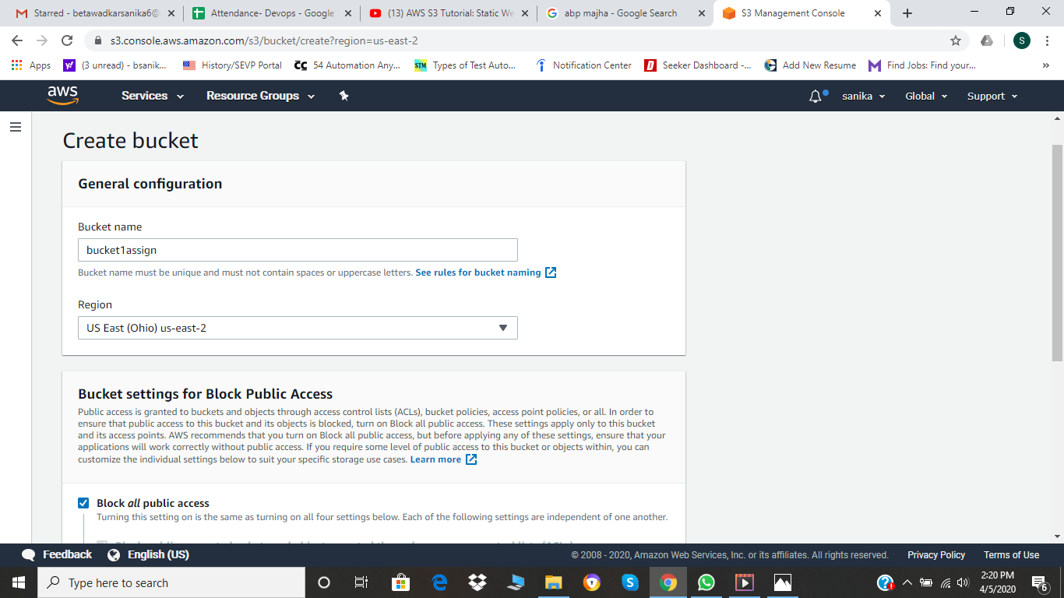

1. I just tried to upload a dummy file to check whether it working or not so I used “ .pdf” file and then is upload. But while working on this I had blocked public access. And due to this when the file was upload on S3 bucket it showed denied and due to this it wasn’t opening. So , to solve it we need to change permissions and make it public.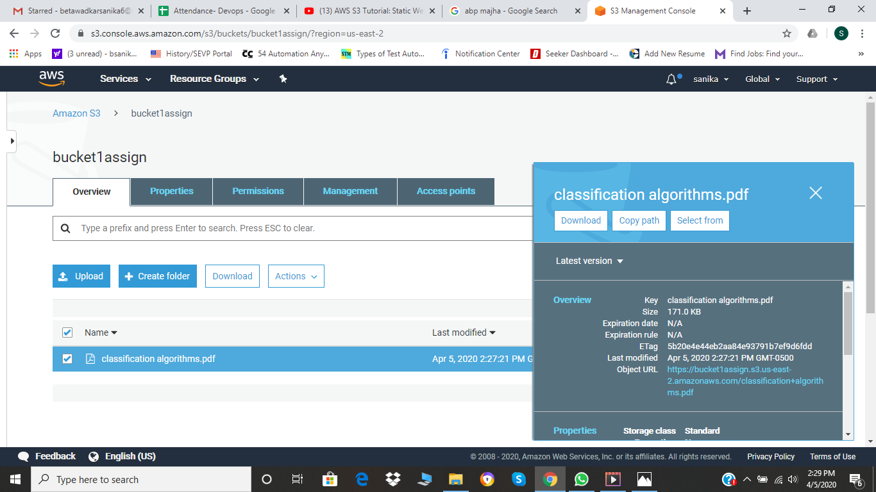
2. I changed the permissions to public and also change the properties of the object by selecting make public.

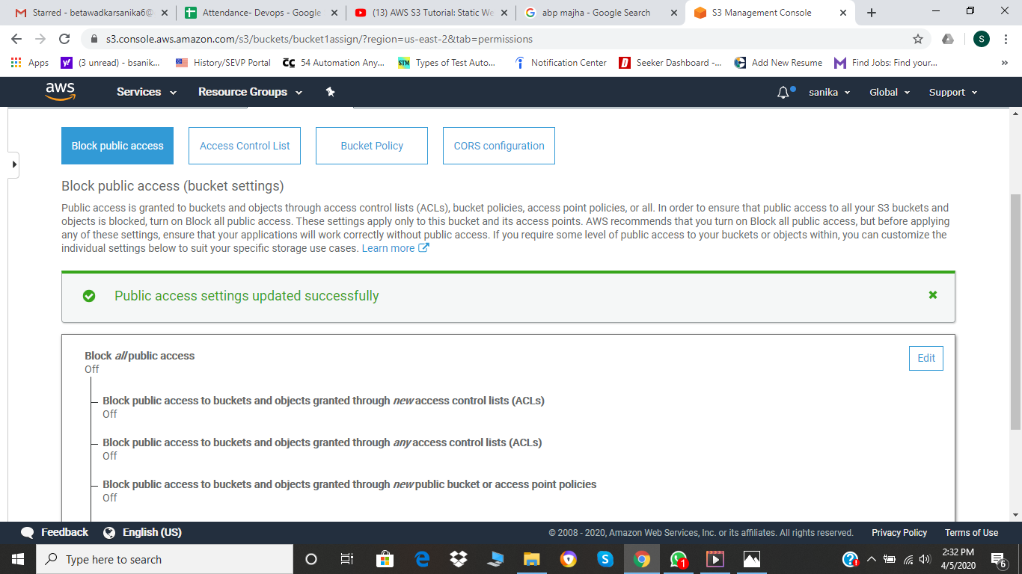

1. Hence the pdf is shown on the url specified. 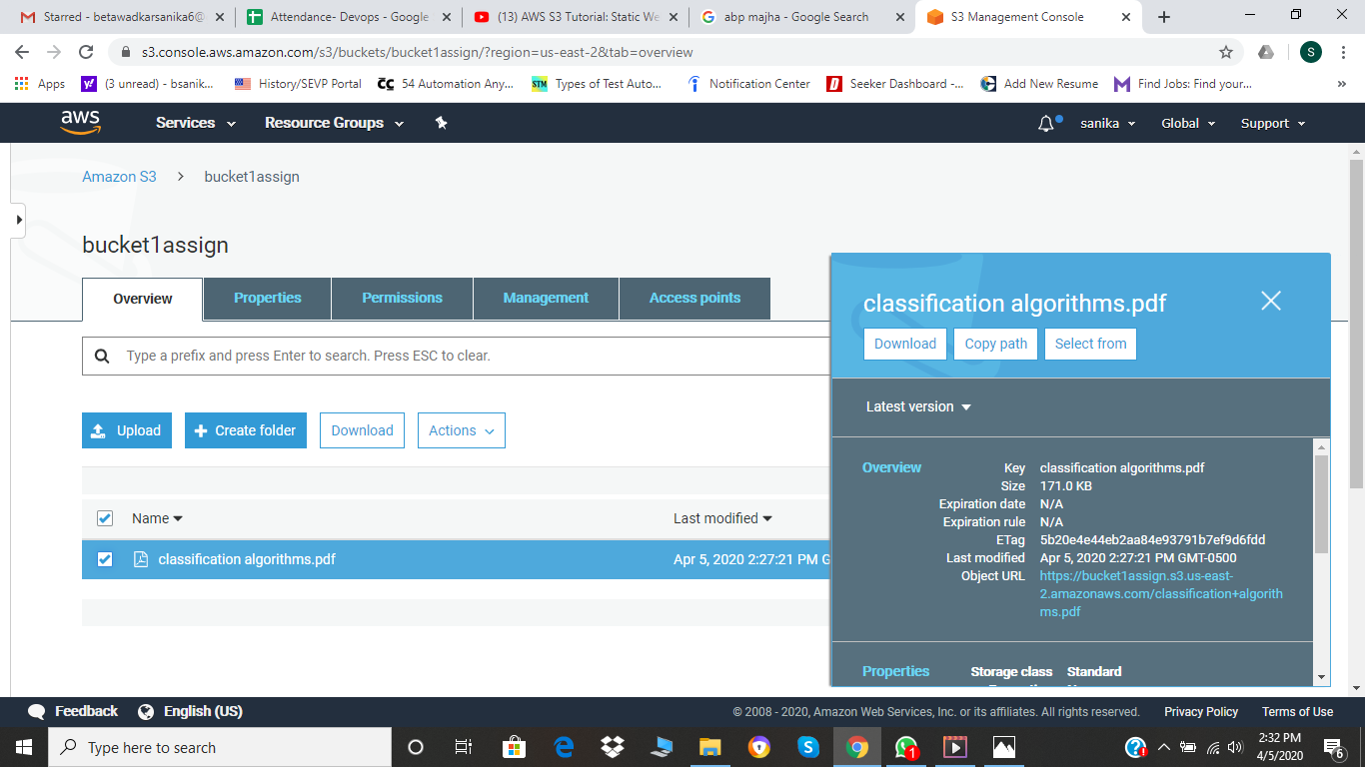

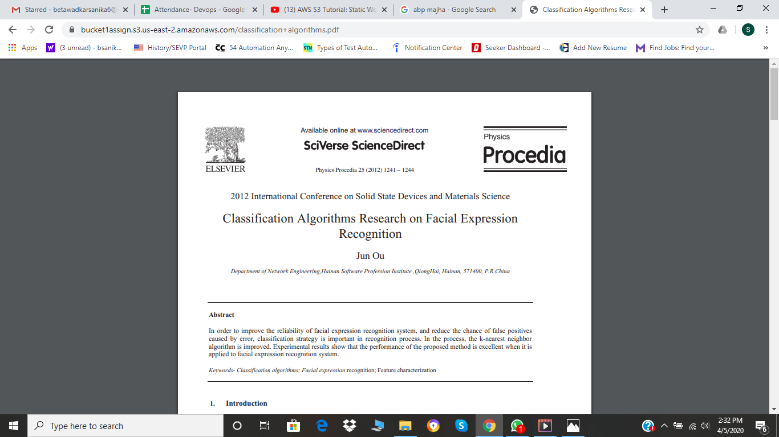

1. Now as we have to host a static weg page, we need index.html and error.html file in the bucket. I had created them before and so I upload it on the S3 bucket as follows and also changed the permissions to public.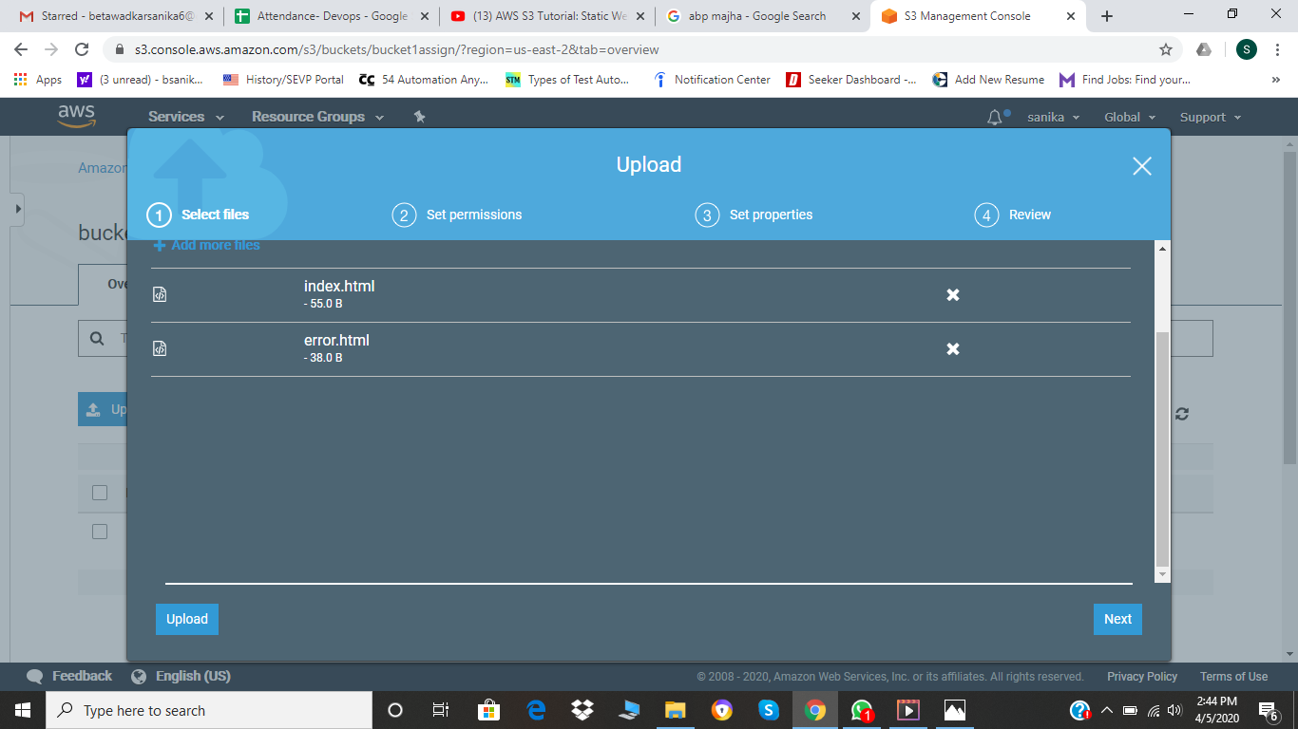

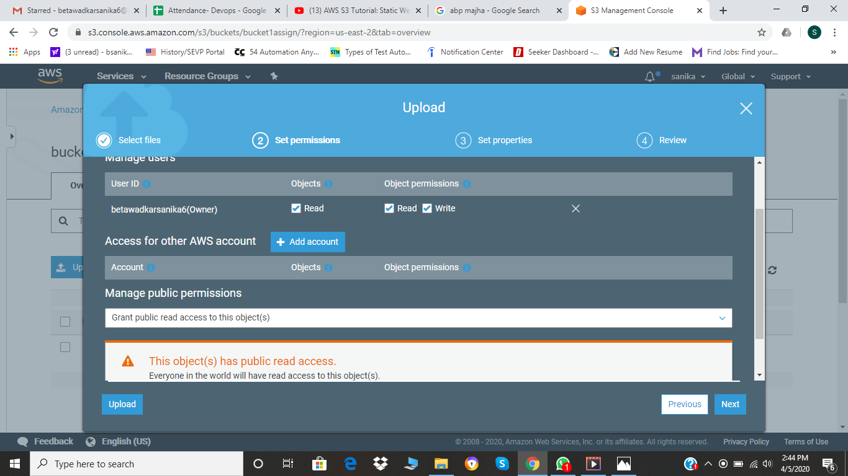

1. The files are uploaded the bucket as shown below.

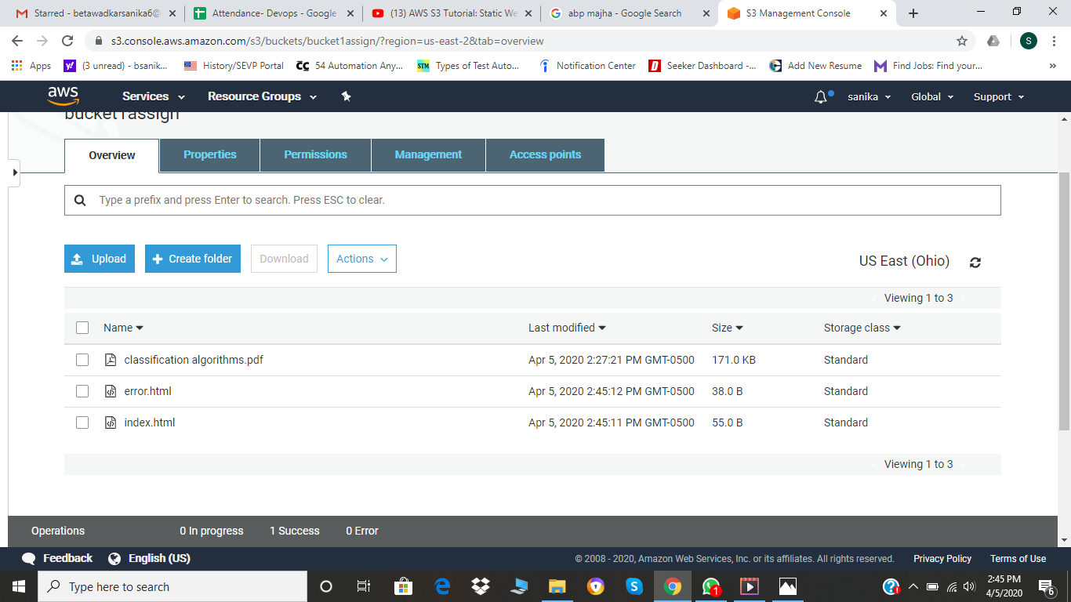

1. Now I selected selected static web hosting by going into properties and selected the downloaded both files i.e. index.html and error.html .
2. Finally just click on the URL (endpoint) and you will get to see you webpage.

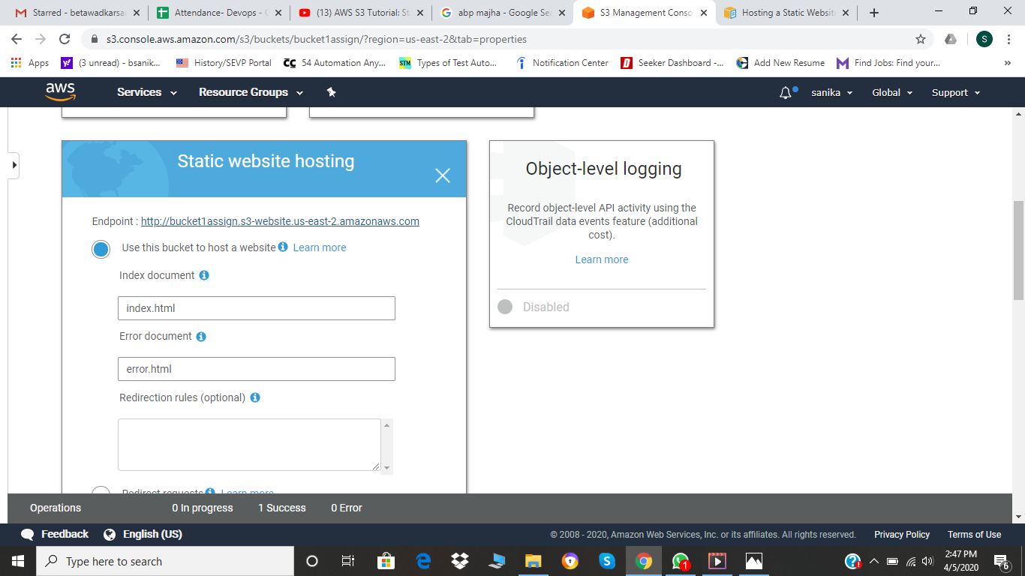

1. My static web page is hosted.

